Light Pollution

Mapping terrestrial light emissions has been done with images from satellites in orbit, of course. And it’s been done with airplanes. But that middle realm, with the balloons operating at about 80,000 feet, should provide a better perspective than a plane and more detail than a satellite. And it is so very much cheaper to pull off than the other two options, assuming the not-insignificant engineering challenges can be solved.

Unfortunately, part of the light directly emitted by outdoor sources and part of the light reflected by lit objects go towards the sky. A portion of that is redirected downwards and a diffuse artificial sky brightness is seen; it is called ‘skyglow’. The artificially lit night has several negative effects on the environment, on plants, on animals and on people ,with the most evident consequence in the loss of visible stars due to contrast reduction .Light polluted skies are seen by more than 80% of people in the word, and they prevent more than one third of the world population from admiring the Milky Way, our Galaxy .It was proven that being exposed for a long time at night to artificial light has a significant effect on the environment, wildlife, and society; furthermore, it also disturbs human health and sleeping rhythms.

* Night-time Earth remote sensing using satellites,14 planes, unmanned aerial vehicle (UAV) or balloons is a growing research are because of its applications in light pollution control, energy efficiency measure, socioeconomic studies, environmental impact, etc. The use of balloons for these purposes overcomes the legal limits in the use of other alternative systems like UAV/drones.
* HAB flights have indicated that non-stable photography of light pollution results in “streaking,” in which
* an image become blurred from considerable motion during exposure
* HAB flights have indicated that non-stable photography of light pollution results in “streaking,” in which
* an image become blurred from considerable motion during exposure
* HAB flights have indicated that non-stable photography of light pollution results in “streaking,” in which
* an image become blurred from considerable motion during exposure
* HAB flights have indicated that non-stable photography of light pollution results in “streaking,” in which
* an image become blurred from considerable motion during exposure
* Getting images that sharp from the stratosphere isn’t easy. Think of a time you tried to snap a photo at night. You need a pretty steady hand. We need to ensure that our cameras would be rock solid while floating nearly 100,000 feet up.

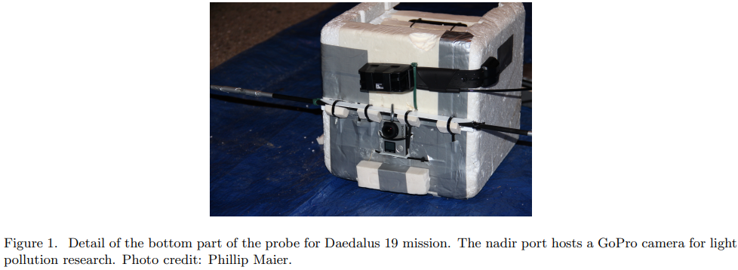

* The proposed system should efficiently measure the luminous intensity and the spectral power density of on-ground emissions providing a useful tool to identify polluting sources and to quantify upward light flux.
* The site is usually observed from a reduced height, achieving good spatial resolution and allowing at the same time use of lens with wide angle of view, which can collect light in directions far from the optical axis. The same site can be observed for an extended period monitoring variation of the luminous flux or instrumentation may be moved for easy repositioning of the flying system and spanning a quite wide area.
* The measurements of luminance, luminous intensity and spectrum of street luminaires and other polluting light sources could be affected by humidity in particular at angles far from nadir of the measuring system. Up to now, outdoor tests were done only in dry conditions, and no correction factor was required

Components Required: -

1. The payloads may be housed in insulated foam boxes/Styrofoam boxes. It may be wrapped in Al foil to provide the basic insulation, as well as radar reflection. Another way to provide better insulation would be to use- Kapton tape, which withstands a temperature down to -269 degrees Celsius
2. Sensors
3. Light Sensor [To measure the light pollution]
4. Temperature [To keep record of the temperature at which the HAB.]
5. Altitude [To keep record of the altitude at which we are measuring the light pollution]
6. Battery(s) (Lightweight), 9-Volt
7. Controller Board- Arduino, Arduino Battery
8. Linear Actuator [To maintain centre of mass of the payload, and ensure greater stability]
9. Cameras [To click images of the surroundings as seen from the payload at high-altitude/ To use monochromatic cameras for a wide-view detection of light pollution .]
10. Telemetry unit – (APRS Tracker, GPS Receiver)

References and additional sources-

1. <https://www.chicagotribune.com/entertainment/museums/ct-ent-adler-balloon-chicago-light-pollution-map-0905-story.html>
2. <https://www.adlerplanetarium.org/blog/far-horizons-mission-nitelite-update/>
3. <https://www.ncbi.nlm.nih.gov/pmc/articles/PMC6928764/>